NAME : Ali Hassaan Mughal BSCS6-BW

Registration NO: 173627

Task 1

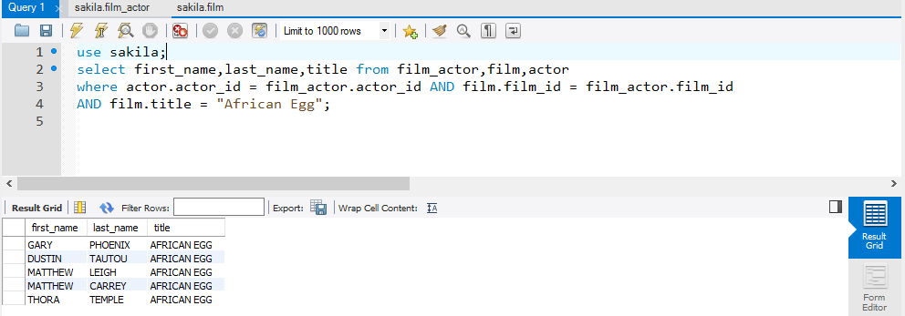

OUTPUT LOG 

Task 3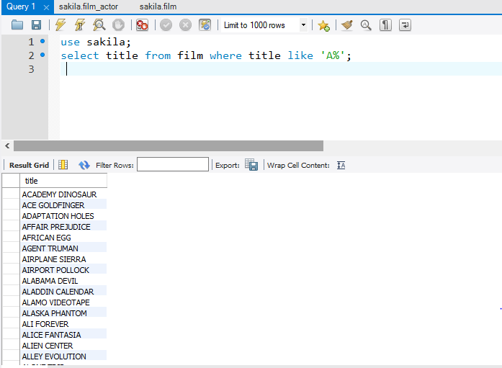OUTPUT LOG

Task 4

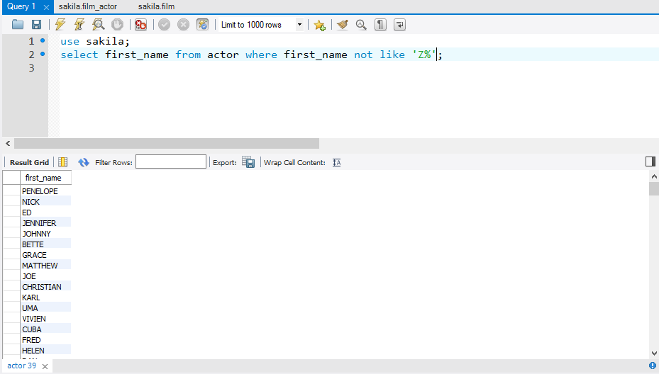

OUTPUT LOG



Task 5

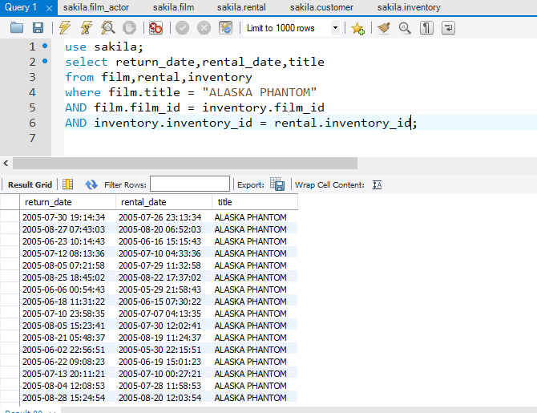

OUTPUT LOG

Task 6

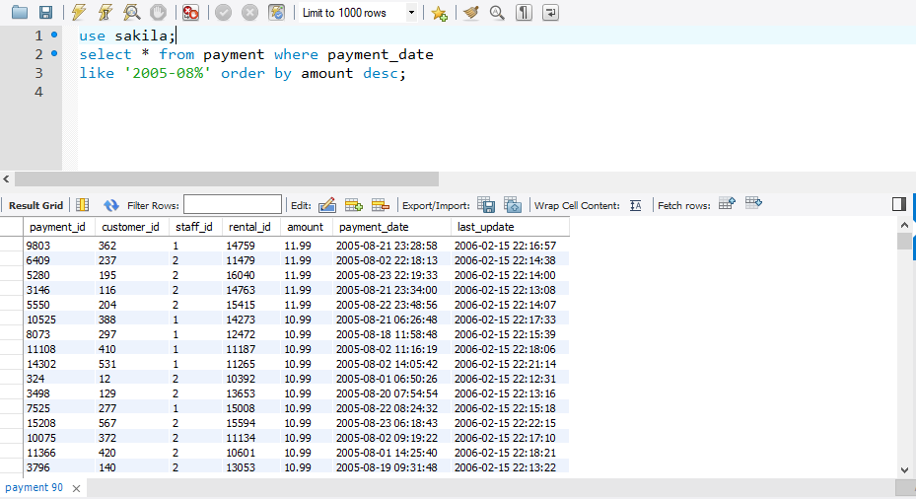

OUTPUT LOG



Task 8

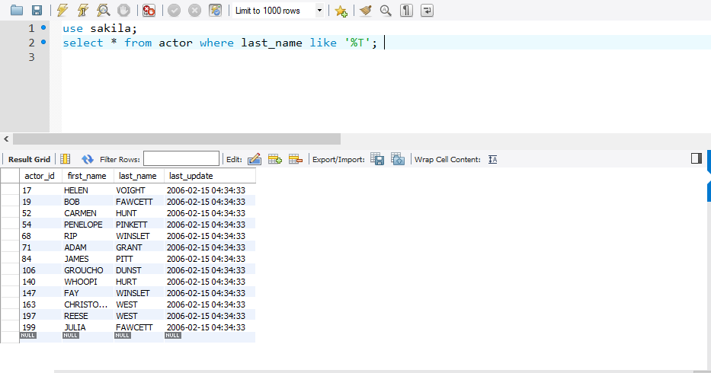OUTPUT LOG